Sample Questions

- Give an example outside of computers when you use an interrupt driven method of checking for the completion of an operation.

- Describe how RAID subsystems improve disk performance.

- Why do most system administrators select a RAID 5 disk subsystems over RAID 0, given that RAID 0 is faster than RAID 5?

- Answer the following questions regarding the PCI bus.

  - What pair of lines are multiplexed together on the PCI bus? (also see part b)

  - What other two pair of lines are multiplexed together?

  - What is the purpose behind the IRDY and TRDY signals?

  - What purpose does the FRAME lines serve?

- What is the minimum number of clock cycles that it would take to transfer 64-bytes of data on a 33 MHz, 32-bit PCI bus?

  - How many cycles would it take if the bus operated at 66 MHz?

  - Identify the use of any additional clock cycles needed to transfer the 64-bytes of data as part of a transaction.

- Each of the following statements about buses has choices shown in italics that can be used to complete the sentence. Circle the word or words that makes the statement true.

  - The address lines of a bus carry the destination or source of the data during a read operation.

  - Buses can be clocked faster when they are short or long and narrow or wide.

  - The width of a bus indicates the number of data or address lines available.

  - The PCI bus has which two lines multiplexed together: address and control and data.

- Describe the reasoning behind creating a memory hierarchy and why locality of reference is important.

- A four-way set associative cache has 50 sets. If memory address 810 is read into the cache, which set does the block go into?

- Referring to the figure below, explain why there is a delay between the address appearing on the bus and the arrival of the data on the third clock cycle.
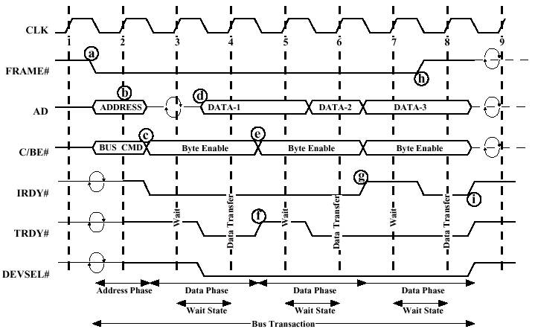

- Mark the following statements that are true with respect to processor caches.

  - It is easier to implement a least recently used replacement algorithm on a 2-way set associative cache than a 4-way set associative one.

  - A fully associative cache behaves similar to a direct-mapped cache.

  - Cache tags are not used with direct-mapped caches.

  - Write-back caches require an extra bit, known as the dirty bit.

  - Slot numbers are not used with associative caches.

  - Bus snooping helps to maintain cache coherency on write-back caches.

  - A write-through cache always maintains the same data in cache as that stored in memory.

- Mark the following statements that are true with respect to RAID subsystems.

  - Smaller data strips permit a single I/O request to be serviced by more disks than larger strips.

  - RAID 5 provides data redundancy by adding XOR data to a single redundant drive.

  - In general, RAID 5 provides faster reads than writes.

  - RAID 1 provides data redundancy, but does not increase read or write performance.

  - RAID 3 is good for supporting a large number of random writes to disk.

